**Sequential Circuit – Core modules**

***S-R Latches***

* Latches are basic building block of flip-flops (Basic memory Unit).
* Two types of memory elements based on the type of trigger that is suitable to operate.

-Latches

-Flip Flops

* Latches operate with enable signal, which is level sensitive, whereas flip-flops are edge sensitive.

***D flip-flop***

- Basic memory storage device.

-For D flip-flop, a clock signal is needed to change states.

- Similar to S-R latch, only we use set and reset function. (Tie D input to s input and not D to R input to make S_R flip flop into D flip flop.

* Block Diagram of D flip flop.
* 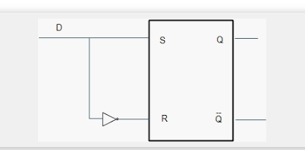

Internal circuit of D flip flop:

* D flip flop is designed using S-R latches.
* D input goes into S and D goes through inverter and feeds into R.

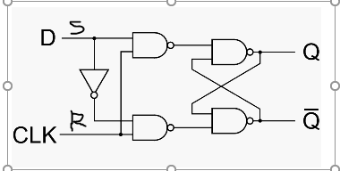

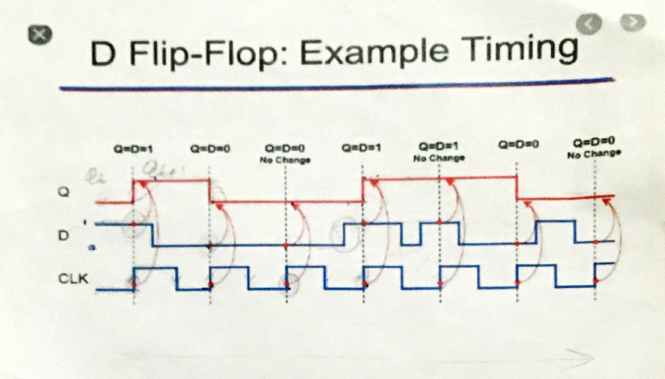

**Sequential Circuit: Core Modules (Cont)**

Internal circuit of D flip flop:

(D flip flop is designed using S-R latches. D input goes into S and D goes through inverter and feeds into R)



**Lets take look at the design of a S-R-flip flop built with NOR gates.**

